
Ljunggren Audio
Roll Your Own
Vertmix

Version: Bipolar mixer/att 1.0

Bill Of Material

Assembly instructions

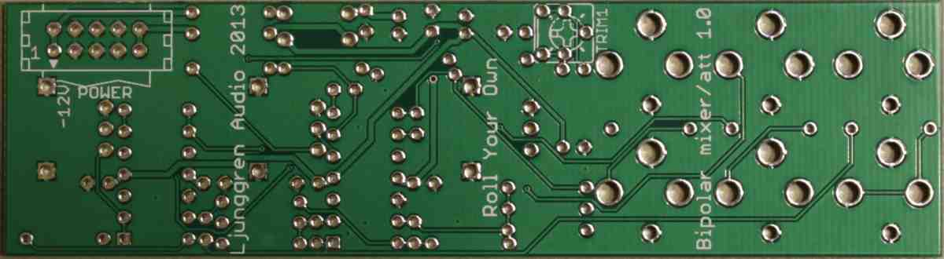
Empty PCB bottom.

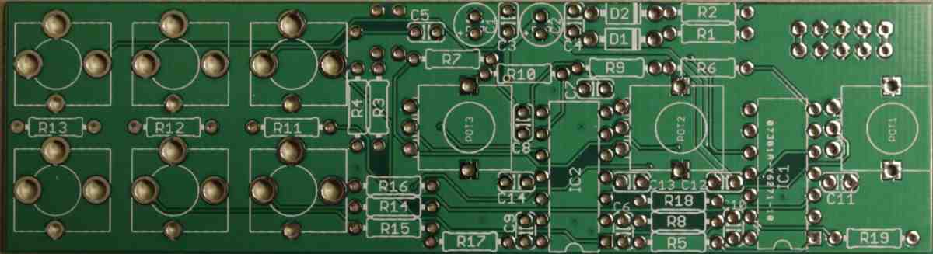
Empty PCB top.

Step 1
Solder resistors. Resistors are not sensitive to mounting direction.

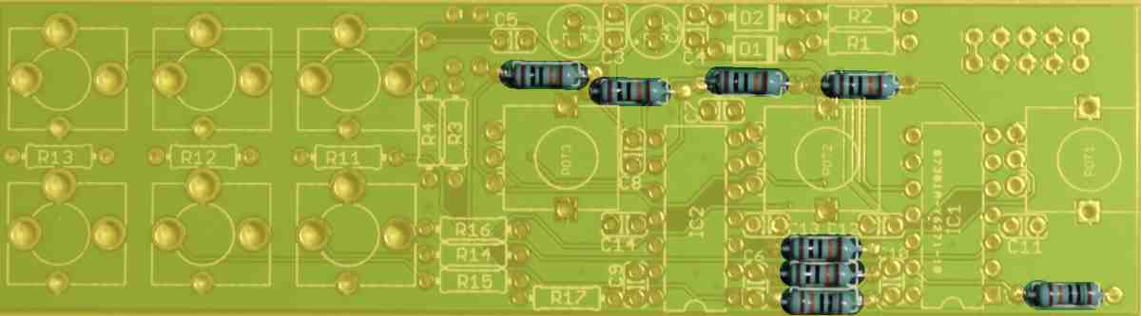
R5, R6, R7, R8, R9, R10, R18, R19 100K

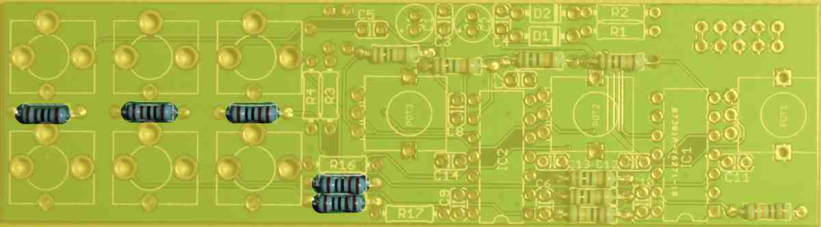
R11, R12, R13, R14, R15 1K

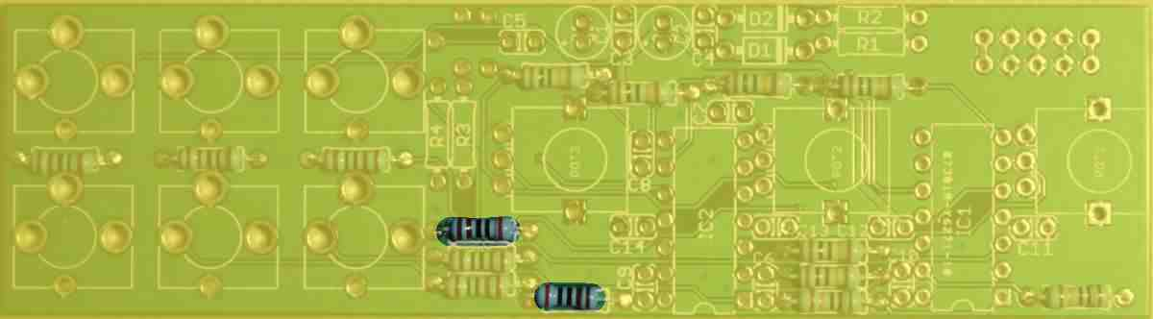
R16, R17 2K

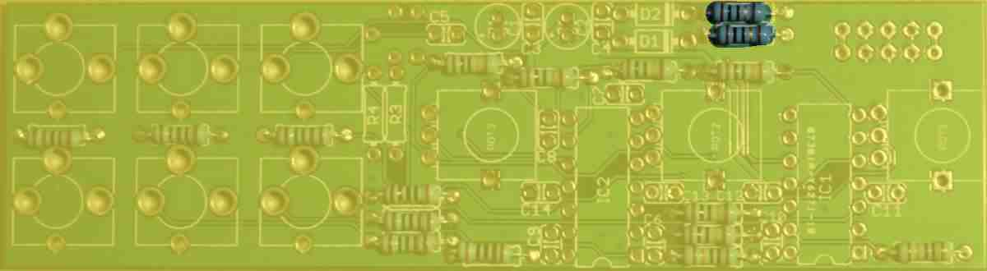
R1, R2 10R

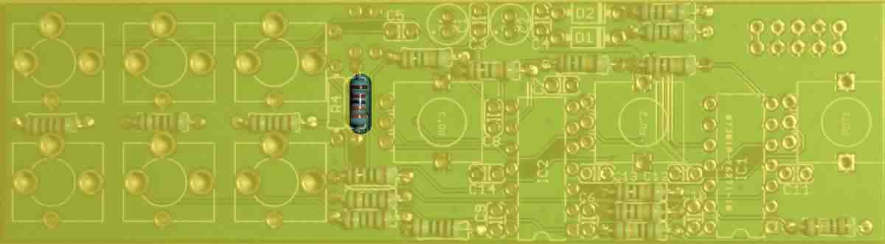
R3 33K

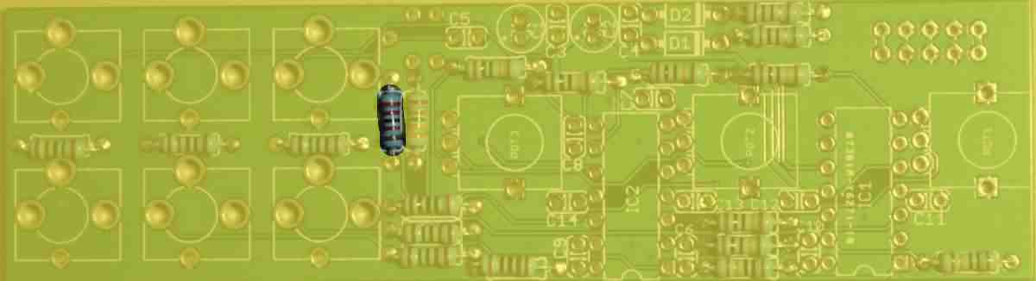
R4 22K

Step 2
Solder reverse polarity protection diodes. The stripe on the diodes must be on the same side as indicated in the silk screen.
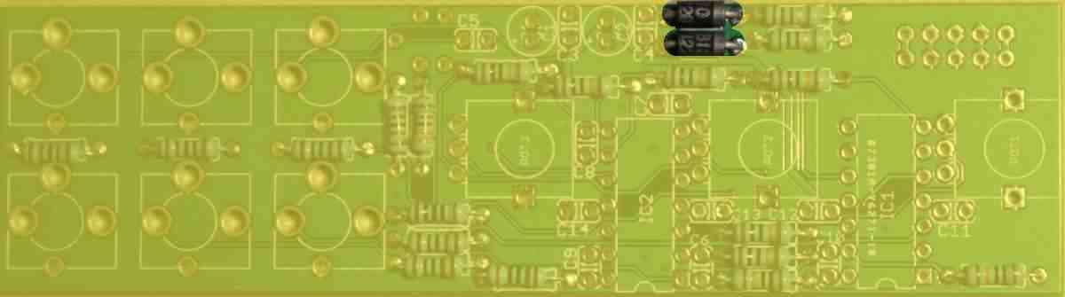
D1, D2 SB130

Step 3
Solder ceramic capacitors. Ceramic capacitors are not sensitive to mounting direction.
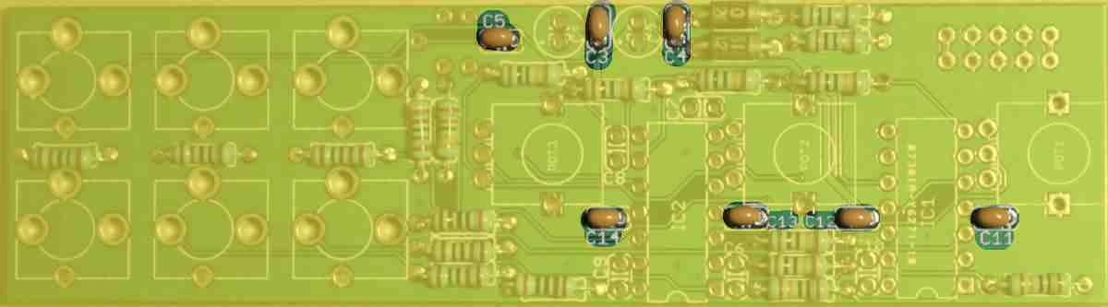
C3, C4, C5, C11, C12, C13, C14 100nF

Step 4
Solder sockets. Match the IC sockets indent (pin 1) with the silk screens. Don't mount the crossed over ceramic capacitors as they are unnecessary.
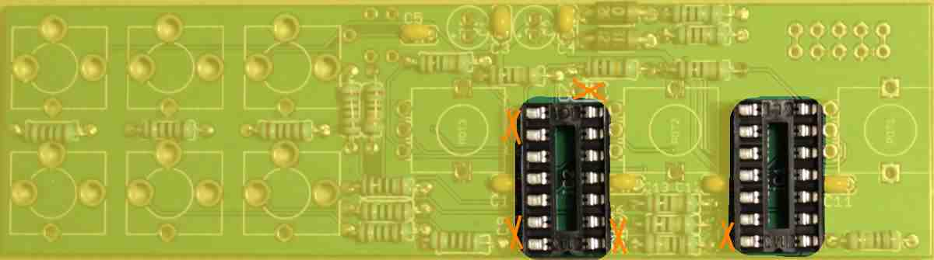
IC1, IC2 sockets. IC's will be mounted later.

Step 5
Solder Electrolytics. Long leg is + (anode).
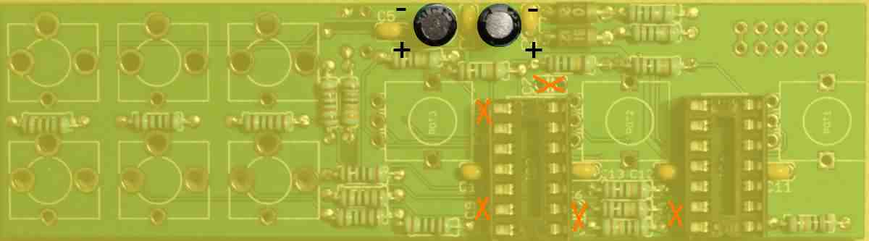
C1 10µF, C2 10µF

Step 6
Solder trimmer. Only 3 of the 5 holes are used, the extra 2 holes are for fitting trimmers with different appearence.
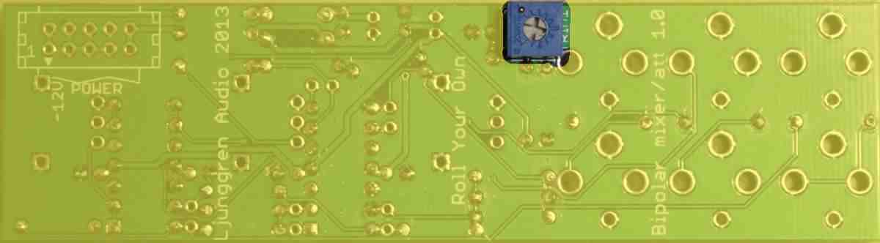
TRIM1 20K

Step 7
Solder the jacks.
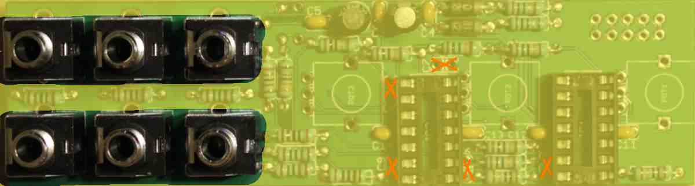
J1, J2, J3, J4, J5, J6 PJ301BM

Step 8
Remove the nuts and washers from the potentiometers. Cut off the small metal tab sticking out indicated by a circle below. Use a cheap plier/nipper for this step, save your expensive ones for other tasks.
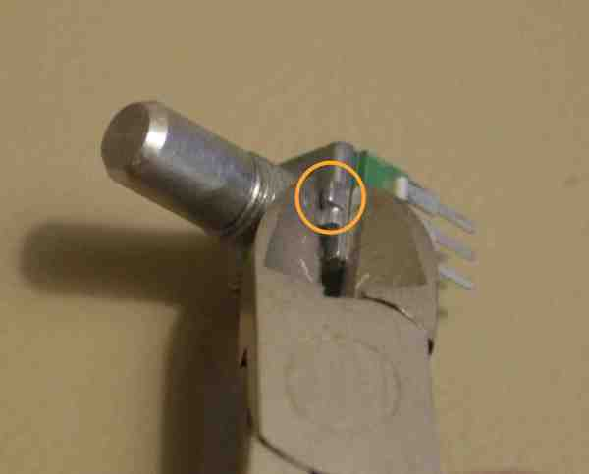
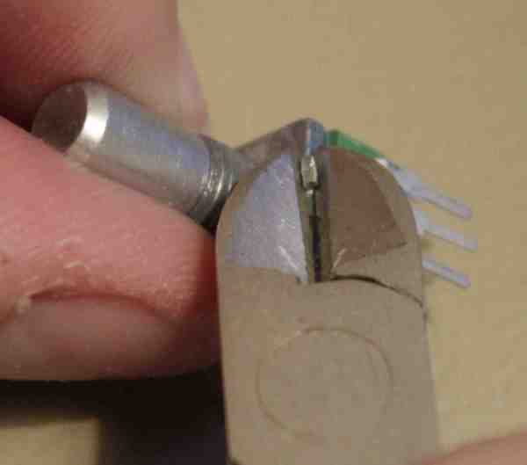
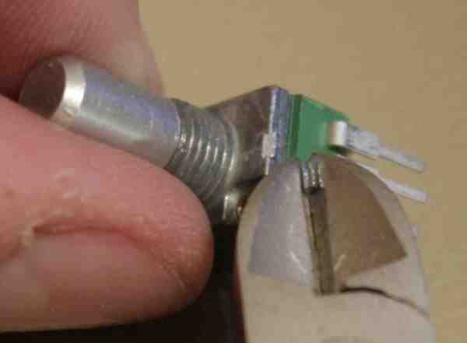
And solder them in place.
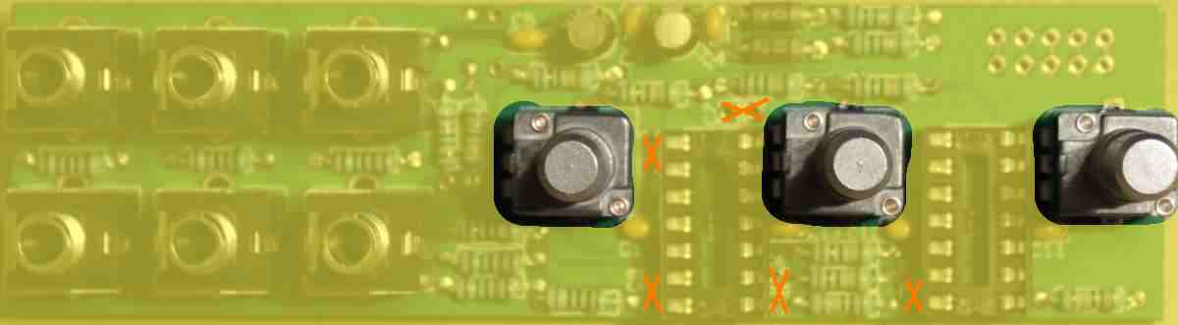
POT1, POT2, POT3 100K linear

Step 9
Solder the keyed boxed power header. Pay extra attention to the direction. The triangle (pin 1) must be at the -12V side. In the picture below you can see the direction of the keyed opening in the boxed header.
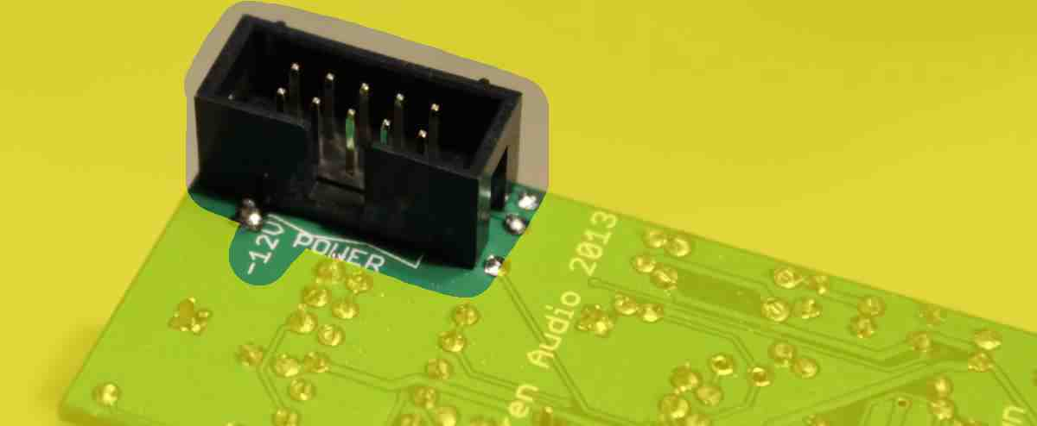
POWER

Step 10
Mount the IC's. The IC's indent or dot marking pin 1 must match the silk screen direction.
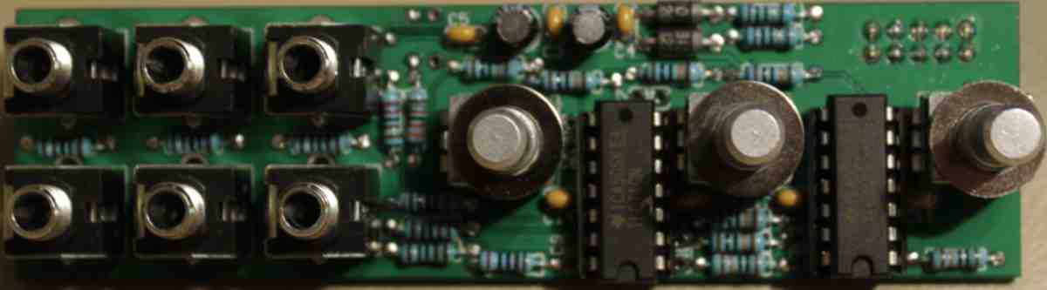

Step 11
Mount the panel. Use 8 mm wrench socket for the jacks and switch and 10 mm for the potentiometers.

Potentiometers: Use the washers that was originally attached to the potentiometers under the panel and the nut over the panel.

Jacks: No washers under the panel. One washer and one nut per jack over the panel.
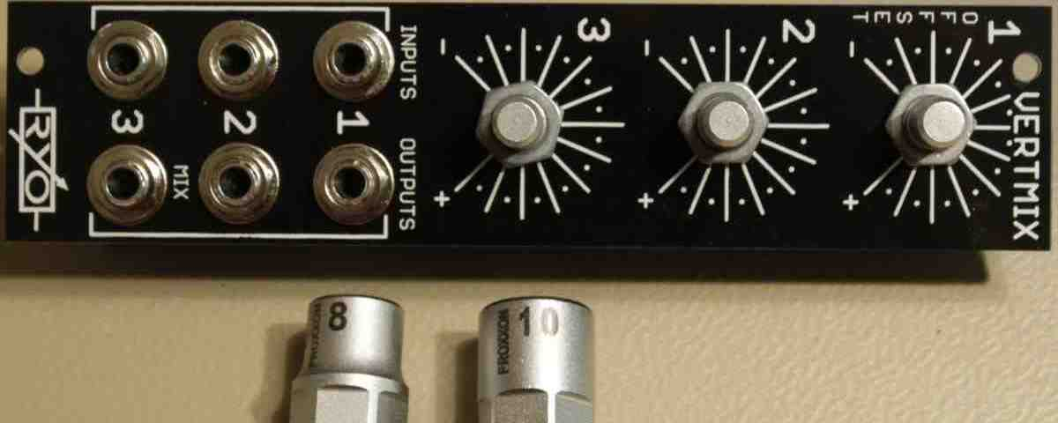

Step 12
Mount the knobs on the potentiometers.
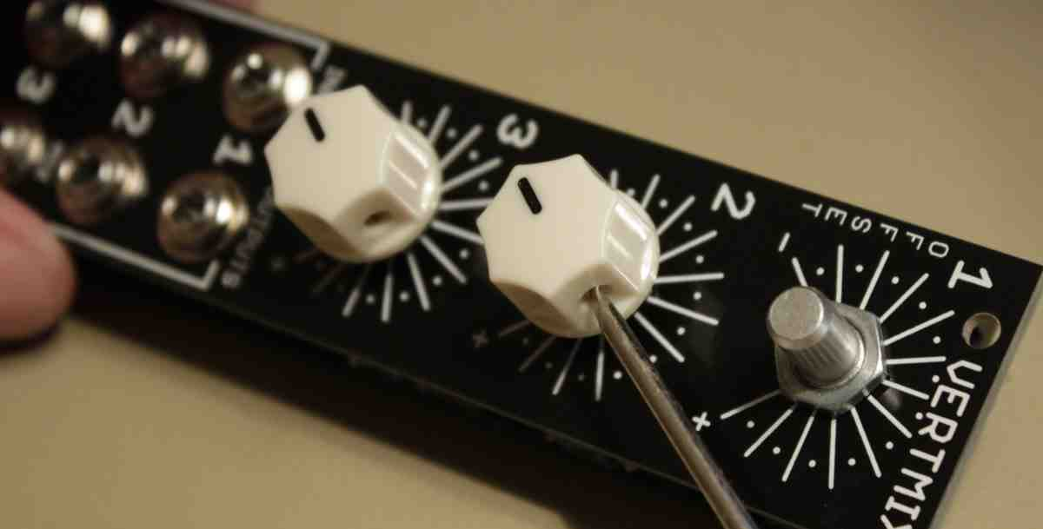

Step 13
Mount the power cable. Red stripe at -12V.

Finished module!

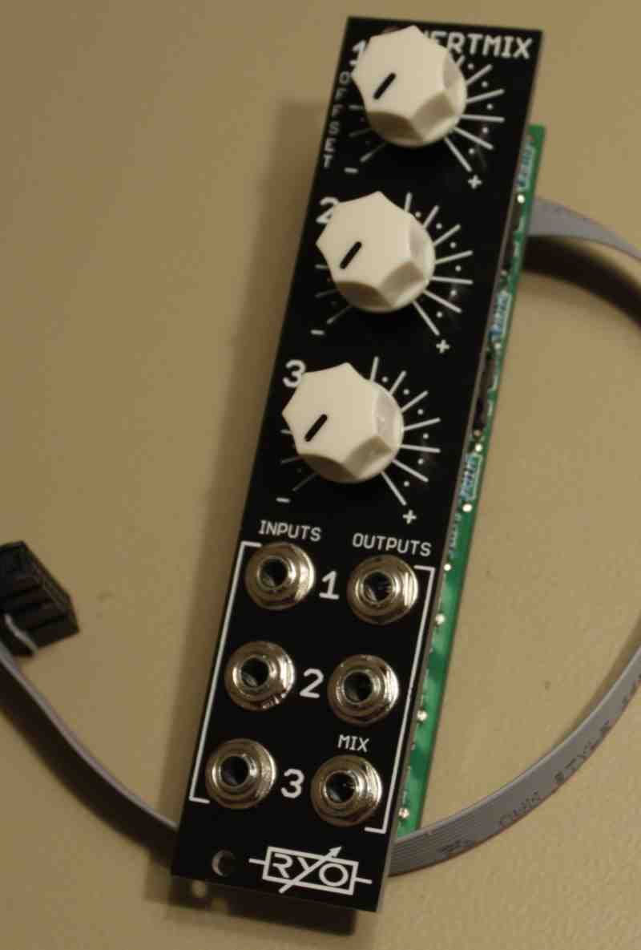

Calibration

1.
Turn channel 1 knob fully CW (right).

2.
Connect a patch cable to channel 1 output. Leave channel 1 input jack unconnected.

3.
Measure voltage with a multimeter between the tip and ring (signal and ground) of the patch cable.

4.
Adjust trimmer until you measure 5V on the multimeter.

There will be some small variations between channel 1 out and mix out as well as between fully negative and fully positive setting, due to the use of 1% resistors and standard opamps with up to 6mV offset. If you use 0.1% resistors where the BOM say 1% and opamps with lower offset you will get better precision for offset, attenuating and mixing.

Although Vertmix have 1k isolation resistors on the outputs so if you patch them to inputs without resistorless buffers there will be a voltage droop and it will increase with passive multing.

